An Interdisciplinary Exercise in Subject-delineated Education

*Barbara Karpinski*

**Introduction**

*“I was surprised because you are good at teaching physics. I thought ALTs don’t teach other subject[s].”   
—first-year Fukiai student, 2019*

*“You’ll be able to speak so many languages, and yet have nothing interesting to talk about.”   
—Karpinski, M., on the importance of supplementing language education with additional subjects, 2013*

Disciplines (or ‘subjects’) are created, changed, and consolidated constantly, a truth never more evident than in the last 50 years of academic curriculum development. Knowledge that the first universities in France categorized into four broad fields of medicine, law, theology, and arts, has now expanded into dozens, occasionally hundreds of separate degree programs in postsecondary institutions around the world. Japan’s Keio University boasts ten undergraduate faculties, of which the Faculty of Letters alone spans seventeen majors (Keio University, 2019). Michel Foucault (1980) distinguished between the ‘specific individual’, an expert in one field, and the ‘universal individual’, whose knowledge is broad, general, and socially constructed. Of course, experts in specific disciplines and professions are integral to the function and progress of society. Doctors and company veterans are relied upon to innovate and stretch the boundaries of human understanding. Yet it is equally critical to recognize that no discipline exists in a vacuum, detached from other subjects. ‘Knowledge’ as the discovery of truth is like a puzzle carefully pieced together. While individuals can focus on one part of the puzzle at a time, or become proficient in, for example, identifying and arranging border pieces, it would be incorrect to say that these individual parts are themselves individual puzzles. The same philosophy regarding holistic education should be instilled in students, both for their personal development to see the value of all academic subjects, and in their academic growth, to be able to apply knowledge in different contexts.

The first quote at the beginning of this paper reflect the fruits of this ideal; students are subconsciously drawing separations between what they learn and who knows what. This same distinction is echoed in every iteration of a student’s complaints; “I don’t want to be an accountant when I grow up, so why do I have to learn math?” and in every explanation of funding cuts to non-core subject resources. The second quote is equally thought-provoking; it was thrown at me when I was looking for guidance on dropping out of all classes that “didn’t suit me” (math, sciences, history, psychology) and focusing only on the ones I liked (French, Russian, German, and other language classes). The ability to socially construct knowledge (and by extent, learn) relies on two factors: subject matter and means of communication, which in principle already combines at least two subject areas. This is the motivation that initially encouraged me to turn to teachers of other subjects and suggest a collaborative lesson. I was pleased to learn that our science teachers, Mr. Umemura, Mr. Kawakami, Mr. Seno, and formerly Mr. Nishigaki saw the value in teaching students that they will need an interdisciplinary education regardless of the field of study they wish to pursue.

**Approach**

The physics in English lesson was generally the same in both years of its implementation. We chose a simple yet active experiment centered around the Law of Conservation of Energy. A weight is suspended between two stands on a string. When the string is cut, the weight swings down and the string is cut again at 0o on a razor attached to the stand. The weight then continues to fall some distance from the stand. Students place a cup on the ground and attempt to catch the weight in the cup. I introduced the experiment in English, going over the materials and then asking students what they believe we will be doing today. Students discussed their ideas with each other, then we shared the ideas as a class and clarified the procedure, as well as what students would need to predict. Each student received a copy of the experiment in English (Fig. 1), a chart of useful vocabulary in English and Japanese (Fig. 2), and a calculator. They were to work in groups of 6-7 to determine how far the weight would fall from the blade, if swung from 0.5m above it and 0.98m off the ground (accounting for the height of the paper cup). During the majority of the lesson, students worked on calculating how far the weight will fall, and teachers circled between groups, assisting where needed in English. During the last five minutes, I wrote each group’s predictions on the board, they prepared their station, and attempted the experiment. Participating students were in first-year general course only.

In the first year, students were given no direction on how to begin calculating their prediction, with the exception of the terms on the vocabulary list (which included concepts they would not need). The success rate of the students’ predictions was approximately one group per class. In the following year, students were given some hints: to use the law of conservation of energy, that mechanical energy was not needed, and that they should divide the calculations into two parts (the swinging weight and the falling weight).The success rate was approximately three groups per class, with a deviation of one group per lesson. This deviation can be attributed to each class’ overall academic level, my instructional inexperience in the first implementation of the lesson, as well as the time of day of the lesson (morning lessons tended to be less active than afternoon lessons).

**Student Worksheets**

Fig. 1 – Workspace

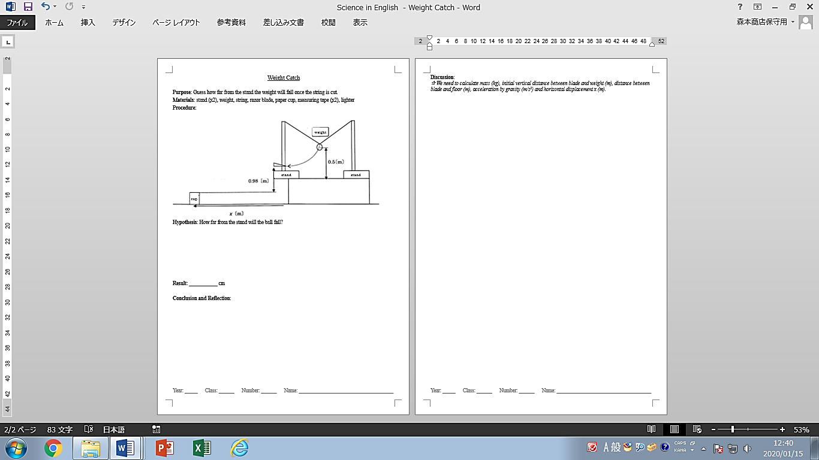

Fig. 2 – Physics Vocabulary

**物理単語 – Physics Vocabulary**

|  |  |
| --- | --- |
| 重さ | weight (*w*) |
| 重力 | gravity |
| 質量 | mass (*m*) |
| 張力 | tension |
| 重力加速度 | acceleration of gravity |
| 摩擦力 | frictional force |
| 弾性力 | elasticity |
| 速さ | speed (*v*) |
| 秒 | second (*s*) |
| 速度 | velocity ($\vec{v}$) |
| 変位 | displacement (*d*) |
| 加速度 | acceleration (*a*) |
| 等速直線運動 | linear uniform motion |
| 等加速運動 | uniform acceleration |
| 初速度 | initial velocity |
| 自由落下 | free-fall |
| 垂直抗力 | normal force |
| 慣性 | inertia |
| 摩擦角 | frictional angle |
| 圧力 | pressure |
| 終端速度 | terminal velocity |
| 仕事 | work |
| 仕事率 | power |
| 運動エネルギー | kinetic energy |
| 重力による位置エネルギー | potential energy |
| 弾性エネルギー | elastic energy |
| 力学的エネルギー | mechanical energy |
| エネルギー保存の法則 | law of conservation of energy |
| ２分の１ | 1 over 2; one half |
| たす | plus |
| ひく | minus |
| かける | times |
| 割る | divided by; over |

107 🡪 10 to the power of 7 102 🡪 10 squared

2-5 🡪 2 to the power of negative 5 103 🡪 10 cubed

例:

ax2 + bx + c = 0 🡪 a x(エイエクス) squared plus b x(ビーエクス) plus c equals zero

**Ask for help if you need it!!**

**Student Feedback**

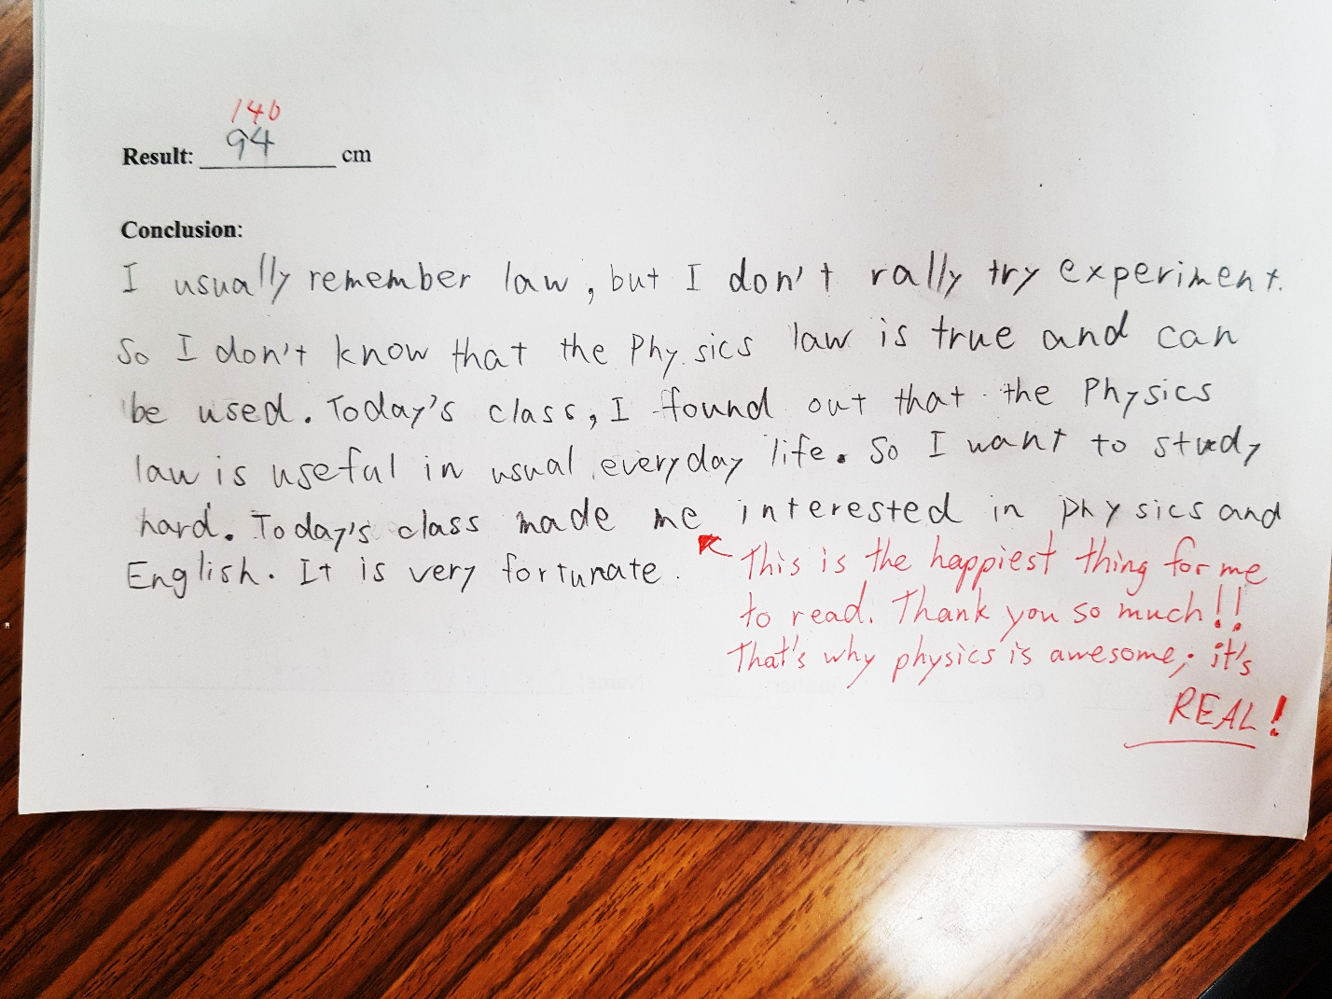

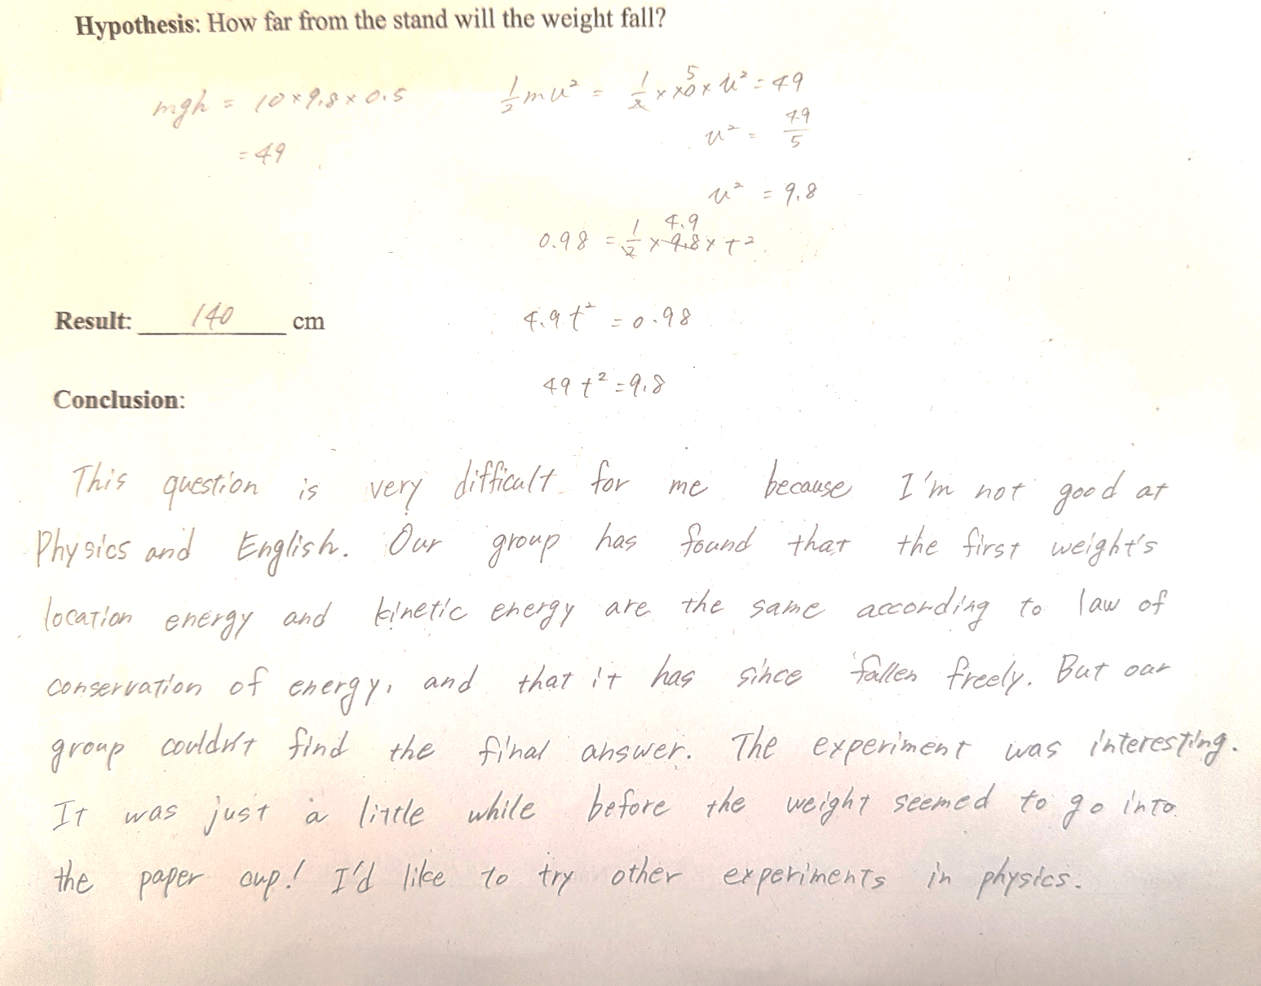

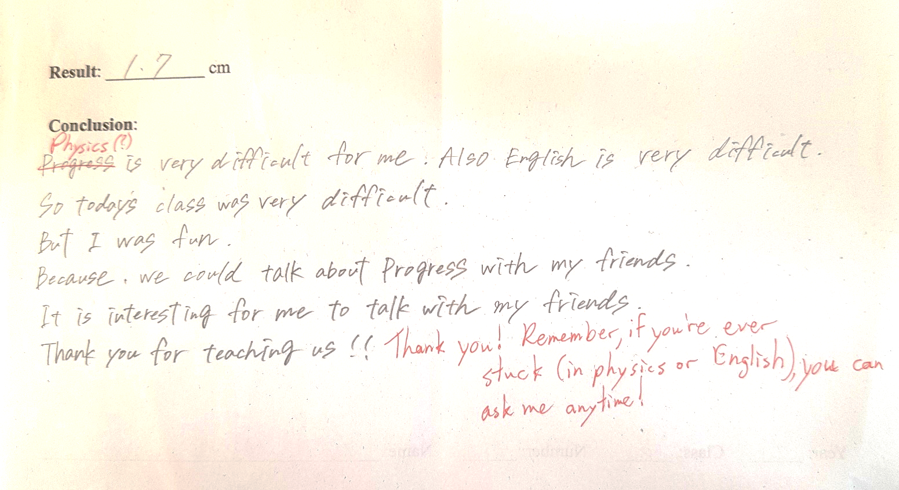

**Reflection from Teachers**

Basia Karpinski (English)

The goals of the lesson were:

1) to introduce students to vocabulary they would otherwise not have learned in English language classes

2) to impart to them the importance of being able to communicate about diverse topics in other languages, in particular in English, which is the common language of academia

3) to draw connections between different subject areas

4) to improve their English communication, especially their ability to explain their logic and to build on others’ ideas

An additional benefit of this lesson was that students who are normally unmotivated in English or physics classes were able to contribute to their group’s progress utilizing skills (English or math or physics) they excel at. Feedback was overall positive with reference to the concept of other subjects taught in English, as well as the level of challenge the lesson presented. As a means to improve this initiative in the future, I would like to work with teachers of other subjects, such as physical education and history, and teach occasional lessons in English. Additionally, students expressed that they would like to do more experiments in English in science class, so if the possibility exists, further chemistry or biology lessons, perhaps in second or third grade, should be planned.

Mr. Umemura (Physics)

　物理の実験を英語で行うという試みは、バシャ先生と物理の教師の間で将来、コミュニケーションを様々な言語で行うことの重要性や世界に目を向けるという意味でも効果的であると考え企画したものである。生徒にはとても良い刺激になったとともに我々が思いもよらない効果を生んだ。

まず、教科への認識の変化である。生徒は「英語は英語、理科は理科」と考えていることが多く、結びつけつけることを意識していなかったようである。今回の感想の中では「学んだことは様々な場面で活用をするものとなると言うことが分かった」と言うものがあり、学びが教科という意識から、身につけ活用していくべきものと言う意識にすることができた。

次に、意欲的な学習ができたことである。最初はなかなかディスカッションができなかったが、徐々にできるようになり、班発表では、（日本語、英語どちらで行ってもよいと言う発表形式で行った。）日本語だけでなく、英語で表現しようとする生徒が出てきた。また、授業後もう一度このような授業をやって欲しいという要望が多々出てきた。

　生徒にとっては思いもよらない形式の授業で驚きが多かったが、様々な表現手段を持つことの重要性や学習の意義などの効果をうみ、よりよい学習活動となった。

Mr. Kawakami (Biology)

物理基礎では普段から教え合いの時間を多く取り入れており，協調する力や表現力の向上に取り組んでいる．その中で今回は英語でディスカッションをしながら班で答えを出すという活動を行った．英語が使えなければコミュニケーションができない状況で戸惑う生徒が多かった．途中，日本語で話す生徒もいたが，日本語の中に英語を少しでも使おうとする生徒，知っている単語だけで伝えようと努力する生徒もいた．この授業を通して，ボキャブラリーが少なくても伝えようとする気持ちがあれば物理のような専門的な領域であってもコミュニケーションがとれることがわかった．また感想の中で，「友達と協力して答えを考えることが楽しかった」と肯定的な意見が多かったのが印象的である．今回のような教科横断型の授業形式は広い視野で教科について考えるきっかけともなる．現状では教科横断型授業は生徒にとって「非日常」であるが，この形式を定期的に行うことの意義を感じることができた．

References

Chettiparamb, A. (2007). *Interdisciplinarity: A literature Review*. The Interdisciplinary Teaching and Learning Group, University of Southampton. ISBN: 978-1-905788-36-1 Retrieved from <https://oakland.edu/Assets/upload/docs/AIS/interdisciplinarity_literature_review.pdf>

Foucault, M. (1980) Truth and Power. In Gordon, C. (1980) (ed.) Power/knowledge:

selected interviews and other writings, 1972-77. Trans. by C. Gordon et al. New York:

Prentice Hall, pp.109-133.

Keio University, (2020). *Undergraduate*. Retrieved from <https://www.keio.ac.jp/en/academics/undergraduate/>